INDEX of ACTIONS - 2017
(V) HOMER PLANNING BOARD

MEETING DATE |  | ACTION  NO. |  | DESCRIPTION
12/20/17 |  | 6 |  | RICHARD OTTENSCHOT, APPLICANT/REPUTED OWNER - 10 Prospect Street - TM #66.65-01-22.000 - Subdivision of Land APPROVED, as requested, with the smaller of the two lots to be consolidated with the applicant's adjacent parcel, TM #66.65-01-23.000.
 |  | 7 |  | APPROVED MINUTES OF 12 DECEMBER 2016 PLANNING BOARD MEETING, as submitted.
 |  | 8 |  | 2018 (V) HOMER PLANNING BOARD MEETINGS set for second MONDAY of each month at 6:30 PM.
 |  |  |  | 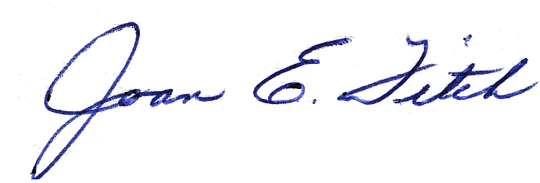
 |  |  |  | Joan E. Fitch, Recording Secretary
 |  |  |  | Sent via email to Mayor, Dep. Clerk (KC), PB Members, DD, Vill. Atty., & CU on 12/21/17. JEF

