INDEX of ACTIONS - 2017
(V) HOMER PLANNING BOARD

MEETING DATE |  | ACTION  NO. |  | DESCRIPTION
11/13/17 |  | NO QUORUM; NO MEETING |  | PRESENT: Don Ferris & Mike Pollak, PB Members; CEO Umbehauer, Board Secretary Fitch, R. Ottenschot, Applicant. No Quorum. Everyone sent home.
 |  |  |  | .
 |  |  |  | 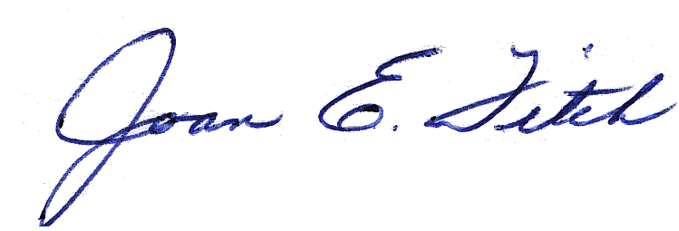
 |  |  |  | Joan E. Fitch, Recording Secretary
 |  |  |  | Sent via email to Mayor, Dep. Clerk (KC), PB Members, DD, Vill. Atty., & CU on 11/16/17. JEF

