The Village of Homer
Annual Climate Smart Progress Report

May 2019 - May 2020
Prepared by: Shenequa Perry

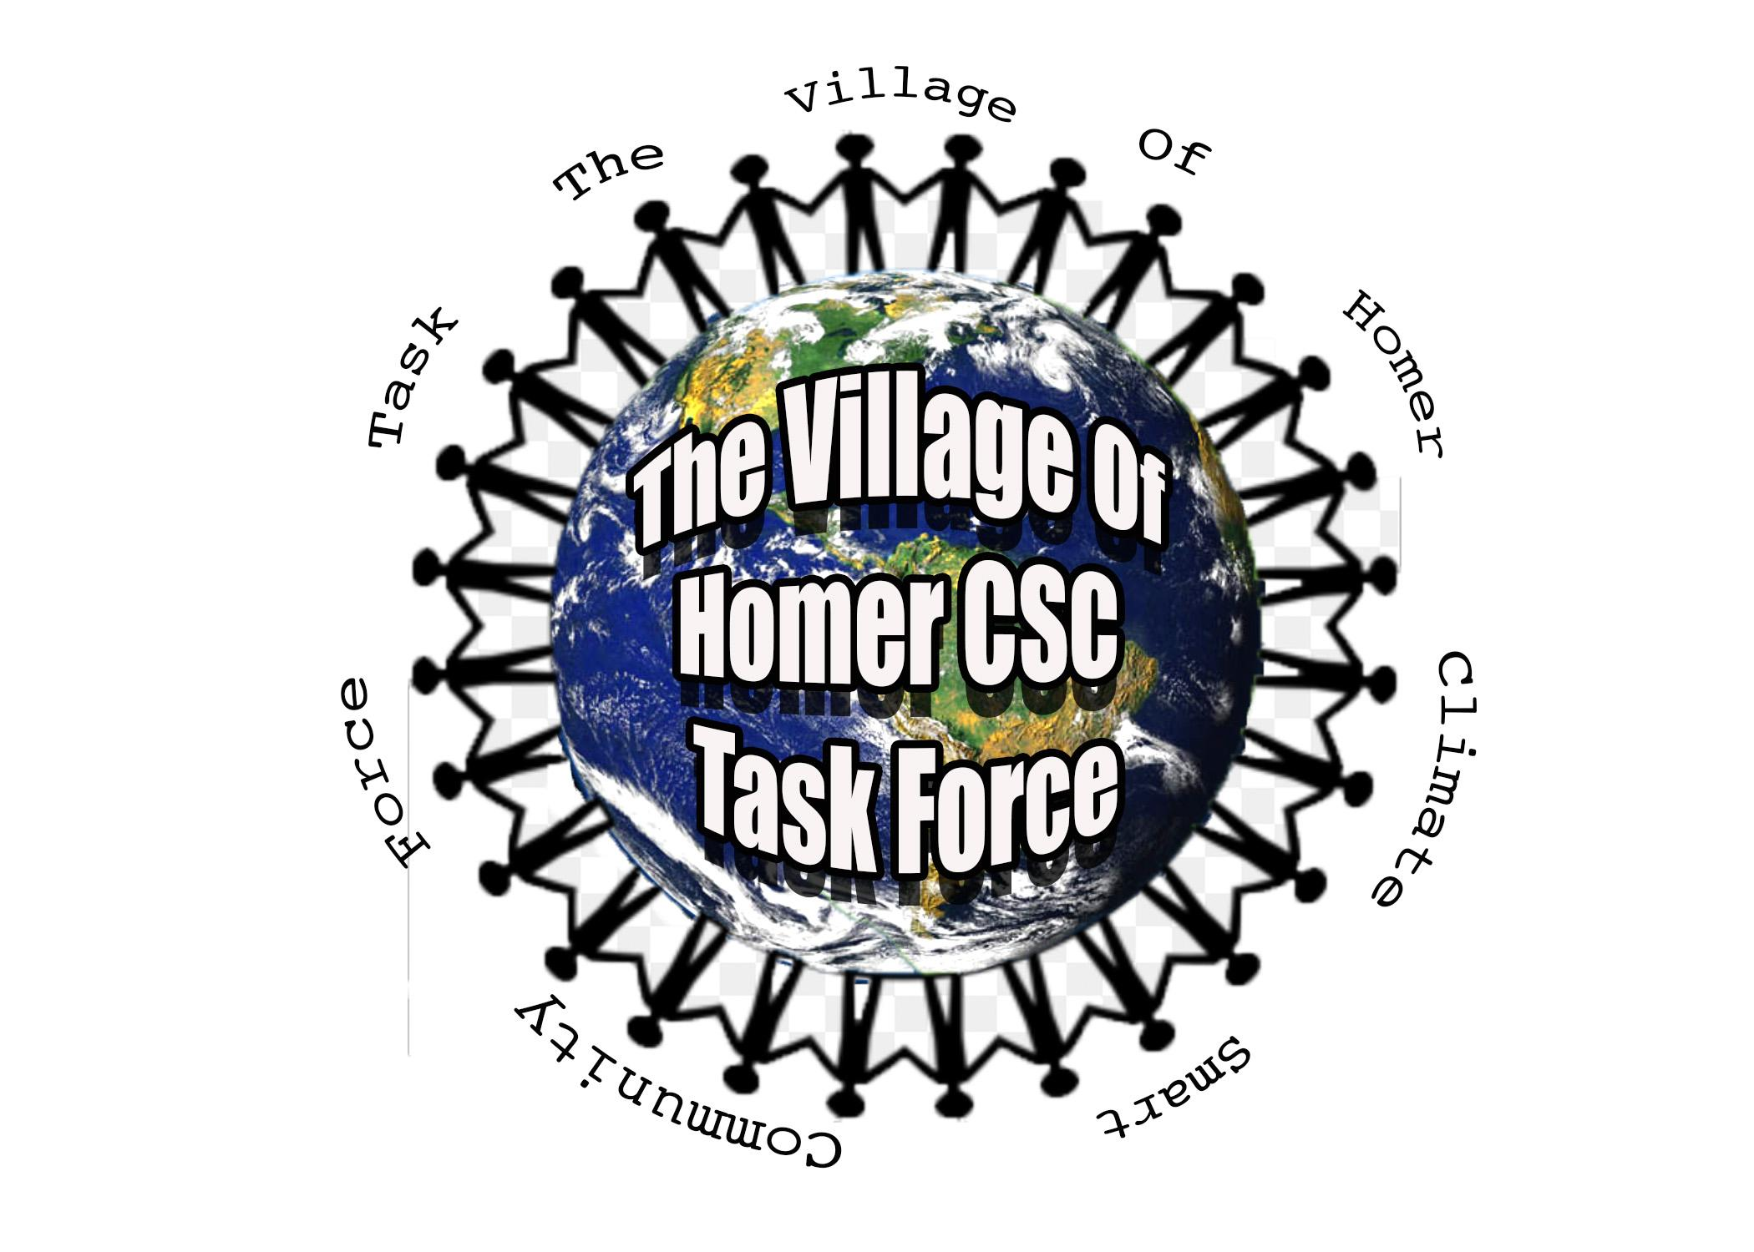
Table of Contents
1- Introduction

2- History
2.1 Government Operations Greenhouse Gas Inventory Results

2.2 Community Greenhouse Gas Inventory Results

2.3 Government Greenhouse Gas Reductions

2.4 Priority Greenhouse Gas Reduction Actions

3- Results and Implementation Status
3.1 Completed

3.2 In Progress

3.3 Not Started

4- Challenges

6- Funding

5- Next Steps

1- Introduction
Climate change is one of the biggest problems that the world is facing and will affect everyone in some way. New York State recently made a leap for the preservation of our climate with the passage of the Climate Leadership and Community Protection Act. This Act sets ambitious and much needed goals for the entire state that will help reduce greenhouse gas (GHG) emissions. The Village of Homer has also been doing its part to reduce GHG emissions by actively making progress on environmental challenges for many years. The Village is a Clean Energy Community through NYSERDA and is currently a registered Climate Smart Community with the New York State DEC (DEC) working to become a bronze certified community. This report will be an overview of what Homer has done, is working on, and is planning to do, to become a certified Climate Smart Community (CSC).

2- History

2.1 Government Operations Greenhouse Gas Inventory Results
During the spring of 2019 students from the State University of New York College of Environmental Science and Forestry, SUNY ESF, with the assistance of the Village, created a baseline government operations GHG emission inventory for 2017-2018. This report will help the Village track emission reductions. This report covers scope 1 and 2 emissions. Scope 1 emissions are defined as emissions that are directly emitted within the Village boundaries and scope 2 being indirect emissions that are produced outside of the Village due to energy use within the Village. This GHG inventory shows that the largest government operations emitter is the water department, followed by the public works department. 72% of the government operations emissions came from energy use, while only 27% came from transportation. These results are used to help inform the village where it has the biggest possibility of improvement and what should be focused on as we move forward. The full report can be found here. https://www.homerny.org/climate-smart-communities/progress/

2.2 Community Greenhouse Gas Inventory Results
This spring, 2020, another group of students from SUNY ESF, prepared a community GHG emissions inventory for a 2018 baseline. This report covered scope 1,2 and 3. This report will help Homer direct and focus its efforts on community wide projects that will cause the largest reductions in community GHG emissions. Transportation was the highest community contributor to GHG emissions, gasoline emissions accounted for about 43% of total emissions and adding in diesel emissions transportation accounts for 49% of emissions. Natural gas use accounted for 36%, electricity was 14%, and the emissions from solid waste was less than 1%. The reduction of these emissions will be headed by the Village, but the participation and cooperation of residents and businesses will be essential in reducing the GHG community wide. The full report can be found at https://www.homerny.org/climate-smart-communities/progress/

2.3 Government and Community Greenhouse Gas Reductions
As the Village of Homer just conducted baseline GHG inventories, no reductions have been documented yet. The Village has completed many projects since the 2018 baseline year that should show reductions in at least the next government GHG inventory. The Village has set reduction goals for government operations of 30% reduction by 2030, and 85% by 2050. These emissions reductions represent our optimistic goals for the future that are in-line with New York State’s aggressive targets to reduce emissions 40% by 2030 and 85% by 2050, from 1990 levels. The Villages goals and plan for moving forward are explained and outlined in more depth in the municipal action plan that can be found here https://www.homerny.org/climate-smart-communities/progress/. Because the community GHG inventory was just completed the Village has not created a community action plan.

2.4 Priority Greenhouse Gas Reduction Actions
For the same reason as stated above, the Village’s priority actions will be focused on reducing government operation GHG emissions at the present. The Village will start by creating climate smart policies such as construction and demolition waste policy, anti-idling ordinance, and green building standards. Homer would also like to conduct a comprehensive energy audit for all village owned buildings, so we will have a better understanding of how energy use and efficiency could be improved. As the water department is the highest producer of GHG, the Village will first direct analysis on its operations to determine the best way to reduce its emissions. Since there is currently no action plan for the community, the formation of it is also a priority so that the Village can plan the best way to reduce the community's emissions. These are just a few of the big-ticket actions that the Village plans to do, a more complete list can be found in the action plan linked in the previous section.

3- Results and Implementation Status
The majority of the actions discussed in the coming sections are directly from the Climate Smart Communities program list of actions, though some may not be directly connected to a specific action.

3.1 Completed
CSC Task Force - This group of residents, students, village officials, and other community members was formed to coordinate the certification process and ensure the environmental sustainability of the village as a whole.

CSC Coordinator - Shenequa Perry was appointed as the coordinator, and Andrew Fagerhiem as the assistant coordinator. Both of these positions are tasked with leading the task force and submitting documentation for certification.

National/Regional Climate Program - The Village is a NYSERDA Clean Energy Community (CEC) and has continued to be an active participant, currently working towards another action for both CEC and CSC, LED streetlights.

Partnerships with Other Entities - The Village has formed a few partnerships, most notably a partnership with SUNY ESF and CNY Regional Planning and Development Board (RPDB).

Government Operation GHG Inventory - The Village worked with SUNY ESF students to form their initial emissions report.

Community GHG Inventory - This spring the Village joined forces with SUNY ESF students again to form the communities first emissions report.

Interior Lighting Upgrades - The Village has been working on replacing all the interior lights with LEDs and this spring it was completed.

HVAC Upgrades - The Village upgraded its HVAC system to a more efficient version; this will help save energy and reduce GHG emissions.

Energy Benchmarking for Government Buildings - As part of CEC the Village started keeping track of their energy use. Every year a new report is created to help inform where the Village is doing well or where there could be a problem that could be fixed.

Energy Code Enforcement Training - This was also a part of CEC. It involved educating code officers about energy code best practices, these may help to make energy more efficient.

Compost Bins for Residents - The Village originally bought 100 compost bins available for purchase by anyone. Those quickly sold out, so we are working on ordering more. Bins are still available, so send in your order form which can be found on our website.

Residential Organic Waste Program - The Village operates a yard waste composting site where village residents can drop off compostable yard waste and take wood chips or compost home with them.

Unified Solar Permit - The Village of Homer has adopted a unified solar permit which will make the approval process of solar systems more efficient.

Alternative-Fuel Infrastructure - The Village as a part of CEC has installed an electric vehicle charging station with two chargers behind the Rec Office that is open for public use.

Farmers’ Markets - The Village took over the Homer Farmers’ Market, providing an opportunity for people to buy local and support local businesses.

Local Climate Action Website - In order to keep everyone up to date and provide ourselves with a place to release the work that we do to the public the task force has created a website.

Social Media - In an effort to increase engagement and knowledge we have created a Facebook page and an Instagram account for the Village task force. You can find us on both platforms @VillageofHomer.csc

Innovative Approaches to Existing CSC Actions - In the creation of our task force we had an innovative approach, letting the next generation lead it. Homer High School students wanted to get involved in their community and help the environment, so the Village let them take the lead. Students make up a large portion of the task force and our coordinator and assistant coordinator are recent graduates or almost there.

3.2 In Progress
Government Operation Climate Action Plan - This is in its final stages. The task force has created the final draft that has been open for review from the public for the last few months and is now going to the Board of Trustees for official approval before July.

Fleet Inventory - At this point we are still collecting information to create the first fleet inventory. This will include all the four wheeled vehicles that the village owns, including what they are, their model year, mileage, MPG, miles driven in the last year, fuel consumed in the last year, and a few other vehicle specifics. This is set to be done by the beginning of July.

LED Street Lights - The Village has been working on replacing all the streetlights in the village with LEDs. This will decrease the electricity used to keep the streets lit, reducing the villages GHG emissions. This action is for both CSC and CEC. This is in its final stages scheduled to be done by the end of 2020.

Recycling Bins in Government Buildings - This action helps to encourage proper waste disposal. Having a recycling bin right next to a trash can instead of across the room increases the likelihood that a recyclable makes its way to the correct place. This is in its final stages and will be done by July.

Construction and Demolition Waste Policy - Creating this policy will help reduce the amount of usable material that ends up in the landfill from construction and demolition projects. Ensuring that materials are disposed of or reused properly. This policy is in its initial stage, writing is about to begin, and the policy should be complete and approved by July.

GHG Tracking System - Having a system in place will make the formation of government operation inventories on an annual basis a simpler and more efficient process. Having an annual GHG emissions report will help the village track its reductions accurately and adjust its action plan as our work progresses. This action is just getting started, not much has been done yet. It would be ideal to finish this soon, but at the latest will be done by the end of 2020.

Develop a Local Forestry or Tree Planting Project or Program - In order to understand the trees that are currently present in our community, we partnered with SUNY Cortland to conduct a tree inventory in the Village. For each tree within the village right of way, we recorded the species, location, size, and canopy cover. The inventory has not been completed yet.

3.3 Not Started
Community Climate Action Plan - This is a priority action for the Village. Much like the government climate action plan (CAP), the community CAP will outline and direct our efforts to make the community as a whole more sustainable. This will start after the Village submits for certification in July.

Government Building Energy Audit - The Village has had an audit done once on their buildings; however, it was not up to the level required for CSC, therefore we plan to do one soon that meets those requirements. This audit will give the Village a better understanding of the energy consumption of all our buildings which will in turn help us determine how those could be decreased in order to reduce GHG emissions.

Green Building Standard for Government Buildings - Though the Village does not plan to build any new buildings, this action can apply to operations, maintenance, or retrofits of existing buildings. We hope to make these standards so that any construction of buildings in the future is in line with our goal and mission to make the Village a more sustainable place.

Fleet Efficiency Policy - After creating the Fleeting Inventory the Village hopes to create an efficiency policy. This policy will provide the guidelines and requirements for future vehicle acquisitions and set standards for fuel efficiency, when commercially available and practicable. The task force would like to complete this policy before July.

Environmentally Preferable Purchasing Policy - An EPP policy would set efficiency and environmental standards for future purchases made by the Village. The products that we buy have a huge influence on the Climate. This policy would help the Village determine the best environmental and economical options.

Green Power Procurement Policy - This policy is a commitment to allocate funding for the purchase of renewable energy, credits, and/or the installation of renewables. This is a great step on the way to reducing emissions and show leadership in shifting to renewable energy.

Renewable Energy Feasibility Studies - In order to implement renewables, it is important to understand which technologies are best for the Village. Doing this study would improve the effectiveness of the energy sources we implement.

Government Solid Waste Audit - A waste audit will help the Village understand what waste they produce and to what extent that that waste is contaminated. This is a great way to help improve waste disposal and track how waste education or other related initiatives help to reduce waste produced. We hope to start doing regular waste audits within the next couple of months.

Recycling Program for Public Places and Events - Having recycling bins in public spaces like parks or the green help to encourage and make it simpler for people to recycle while they are out and about. Events can produce a lot of waste and making sure that the proper waste bins are present can severely decrease the amount of waste going to the landfill.

Waste Reduction Education Campaign - This campaign has not been planned in any way but is something that the Village would like to do. Learning how to reduce our personal wastes can save us all money. We would also like to make waste reduction and proper disposal less complicated for everyone. The task force would like to get this going soon, especially given the confusion with the changes that have been going on with recycling in Cortland County.

Complete Streets Policy - This policy will help make the streets of Homer better equipped for all forms of transportation, whether that be driving your car, riding a bike, or just walking. This is a complex and time-consuming policy to create, though it is one of priority for the Village.

Planning and Infrastructure for Bicycling and Walking - This goes hand in hand with the Complete Streets Policy. Complete streets apply to all forms of transportation including biking and walking. Planning and making changes to the Village streets that would make it safer and easier for cyclists and pedestrians to move, will encourage more people to use a carbon neutral form of transportation around the Village, helping to reduce GHG emissions.

Natural Resources Inventory - This inventory would catalogue all of the Villages natural resources, both physical (geology) and biological (forests). Providing a foundation for the Villages land-use and conservation planning.

Climate Vulnerability Assessment - Climate change does not affect everyone and every place in the same way. A vulnerability assessment would help identify and address the major threats that the Village is likely to face in the future with continued climate change.

Climate Smart Resiliency Planning - This includes a survey of existing plans, policies, and projects, with the purpose of finding vulnerabilities that could be fixed to improve the Village’s resilience to climate change. Once this survey is completed, actions can be taken to fill in the gaps.

Climate Adaptation Strategies - After the Village completes the vulnerability assessment it can turn to making a strategy to address what was discovered.

Buy Local/Buy Green Campaign - Buying local and buying green can help reduce GHG emissions and help improve the local economy. The Village wants to help facilitate and support this initiative.

Climate Change Education and Engagement - In order to take action toward improving climate change we all must understand it. And in order to implement action we must work together. The Village hopes to find an effective way to educate and engage its residents.

Energy Analysis of the Water Department - This is not a specific CSC action, but because of the fact that the water department was the highest GHG emitter the Village would like to take a deeper look into the department to assess where improvements could be made. This could be upgrading equipment to more efficient versions or making repairs, or simply changing some of the operations slightly.

Efficient Lighting Controls - In an effort to reduce GHG emissions the Village wants to implement projects that will help them use less energy. Lighting is an easy and effective target to reduce some energy use. Turning off a light, putting in more efficient lights like LEDS, or dimming them, can decrease the energy they use and thus the GHG they emit. This is not a specific CSC action.

Fuel Efficient and Alternative Vehicles - The Village would like to invest in more fuel-efficient vehicles as well as increase their use of alternative vehicles to reduce the GHG emissions they create from transportation. This will be a long-term action, slowly replacing vehicles as they get old and/or funding allows. This is connected to a few CSC actions.

Village Employee Engagement - In order to effectively reduce the GHG emissions of government operations all Village employees must be involved, that is why the task force wants to help improve engagement. It will take everyone's corporation to turn the Village of Homer, both its government and its community, into a sustainable place that is taking actions to make the world a better place for future generations.

Reduce Plug Load -Plug load or phantom load is the electricity that is used by electrical appliances when they are plugged in even if they aren’t in use or even on. A computer can still be using energy when it is turned off if it is still plugged into an outlet. This action would involve implementing technology that reduces plug loads or just beginning to have employees unplugging what they can when they leave for the day.

The following chart breaks down how many points each action is worth and how many points the Village has in each category. Any actions with an * in the points column do not have specific points associated with them.

Completed | Points | In Progress | Points | Not Started | Points
CSC Task Force | 20 | Government Operation Climate Action Plan | 16 | Community Climate Action Plan | 16
CSC Coordinator | 10 | Fleet Inventory | 4 | Government Building Energy Audit | 16
National/Regional Climate Program | 3 | LED Street Lights | 10 | Green Building Standards for Government Buildings | 5
Partnerships with other Entities | 3 | Recycling Bins in Government Buildings | 3 | Fleet Efficiency Policy | 3
Government Operations GHG Inventory | 16 | Construction and Demolition Waste Policy | 2 | Environmentally Preferable Purchasing Policy | 4
Community GHG inventory | 16 | GHG Tracking System | 5 | Green Power Procurement Policy | 4
Interior Lighting Upgrades | 5 | Develop a Local Forestry or Tree Planting Project or Program | 1 | Renewable Energy Feasibility Studies | 4
HVAC Updates | 2 |  |  | Government Solid Waste Audit | 2
Energy Benchmarking for Government Buildings | 4 |  |  | Recycling Program for Public Places and Events | 3
Energy Code Enforcement Training | 5 |  |  | Waste Reduction Education Campaign | 2
Compost bins for residents | 2 |  |  | Complete Streets Policy | 4
Residential Organic Waste Program | 2 |  |  | Planning and Infrastructure for Bicycling and Walking | 5
Unified Solar Permit | 5 |  |  | Natural Resources Inventory | 10
Alternative-Fuel Infrastructure | 8 |  |  | Climate Vulnerability Assessment | 16
Farmers markets | 3 |  |  | Climate Adaptation Strategies | 8
Local climate action website | 3 |  |  | Buy Local/Buy Green Campaign | 2
Social Media | 3 |  |  | Climate Change Education and Engagement | 4
Innovative approaches to existing CSC actions | 5 |  |  | Energy Analysis of the water Department | *
 |  |  |  | Efficient Lighting Controls | *
 |  |  |  | Fuel Efficient and Alternative Vehicles | *
 |  |  |  | Village Employee Engagement | *
 |  |  |  | Reduce Plug Load | *
Total | 115 | Total | 41 | Total | 108

4- Challenges
Luckily the Village and the task force have not run into any big challenges. The most challenging things thus far have been finding and collecting the correct data or documentation to submit to the DEC. It has also been difficult to find and devote the time and energy needed to complete all the actions that we want to, as everyone volunteers their time to the task force.

5- Funding
Currently we have no funding beyond the available funds from the village. However as we start looking into doing larger and more costly projects we will look for funding. Being a registered CSC and soon to be bronze certified gives the village more access to grants and funding for projects related to the program.

6- Next Steps
As the Village is almost ready to submit for bronze certification, the task force will be beginning to look beyond that in July. Working toward silver certification will be a more difficult and a longer process. To start off that journey we will focus on the community climate action plan. When both government and community actions plans are complete the Village and task force will begin completing the plans laid out in both reports. We will maintain up to date inventories and track our emissions reductions. When the new GHG emission inventories are done we should see a reduction in our overall emissions, demonstrating that we have made progres to make our Village a more sustainable community, taking the first steps to protect the climate for future generations.

