May 28, 2019

The Homer Village has appointed Shenequa Perry as the Community Coordinator, and Andrew Fagerheim as the Assistant Coordinator.

The Community Coordinator will oversee Scheduling meetings, keeping minutes, organizing tasks for other members, and submitting documents for certification.

The Assistant Coordinator will fill in at meetings when the Coordinator is not present and will help the Coordinator with their tasks.

Signed,
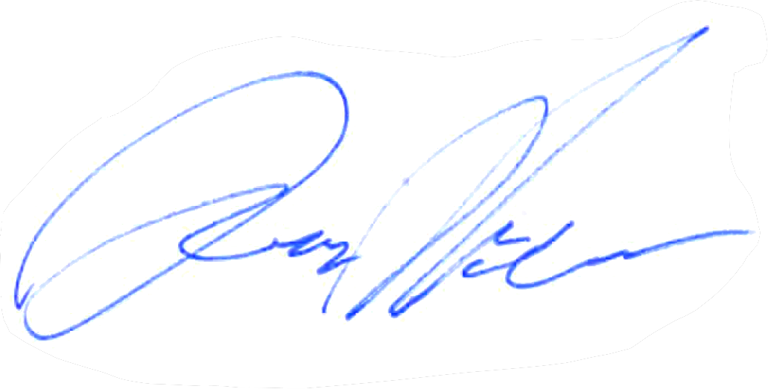

Darren “Hal” McCabe
Mayor, Village of Homer, NY

