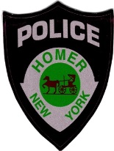

Traffic Advisory

Street Repairs - Beginning tomorrow at 6am, September 26, 2017, Albany Street from South Main Street to the village line (Lighthouse Hill Road / Locust Avenue intersection) will be closed for repairs until Friday, September 29, 2017. Emergency Traffic only will be allowed through. Please plan ahead and use an alternate route.

